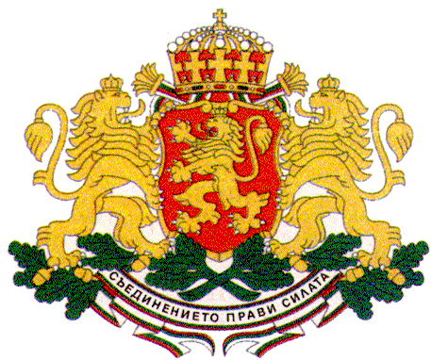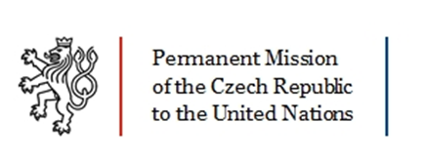

Permanent Mission of Italy Permanent Mission of Bulgaria

to the United Nations to the United Nations

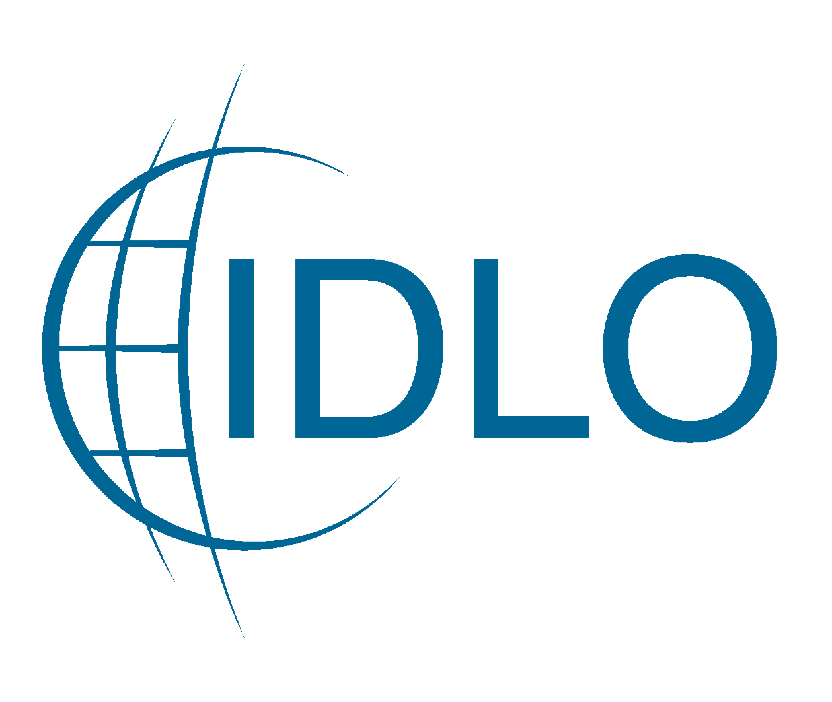

Bulgarian Gender Research Foundation

59th Session of the Commission on the Status of Women

**“Productivity, Well-being and Gender policies”**

*Thursday, 12 March, 3.00 pm – 4.15 pm, UN Dag Hammarskjold Library Auditorium*

Through the adoption of specially designed work – life balance policies, institutions and organizations can help attract and retain talent, improve job satisfaction, and promote employees’ well-being, all of which are important prerequisites for better competitiveness, business growth and sustainable development. Lower employment rates for women as compared to men is often a consequence of the higher involvement of women in family life and the raising of children which creates greater difficulties for women to combine family and professional life and to pursue a career. This is sometimes combined with laws and regulations that hinder women’s ability to earn an income, make decisions about property or start a business.

The Italian Family Audit Certification has recently been awarded as one of the examples of good practices in benchmarking in Europe. Started initially as a regional project it now operates nationally since 2012. The process of certification is a management tool that promotes cultural and organizational change within commercial or public-sector organizations through the adoption of human resources policies that improve the well-being of employees with particular attention to women and their families while furthering the mission of the organization. This policy model focuses on the concept of family mainstreaming by strategically linking it to the principles of gender equality.

The Bulgarian Government is providing affordable and high quality social services as a successful instrument for supporting parents and children, and for promoting women’s employment. Support to parents in combining professional and family life is carried out through special programmes aimed at promoting the role of the father in the family by providing incentives for men to use parental leave; ensuring gender equality on the labour market; developing opportunities for flexible employment and professional mobility of the work force; enhancing the control on the implementation of the relevant labour legislation, etc. The Government is working in active collaboration with the civil society for achieving better results on all issues related to gender equality.

The Government of the Czech Republic has recently taken a number of steps to promote gender equality. The Strategy for Gender Equality for 2014 – 2020 has been adopted, Gender Impact Assessment Methodology created and gender audits promoted. Those measures should accelerate achieving gender equality at the labour market, well-being of the whole society and ensure effective implementation of gender mainstreaming in all governmental policies.

Around the world, women do not have the same legal rights and privileges as men to work, travel, earn or carry out a business, and that affects not only the lives of women but economic competitiveness of the countries. The International Development Law Organization (IDLO), a Rome-based intergovernmental organization, works to ensure that women are provided equal protection under the law.

The event is an opportunity to demonstrate, through national experience, that good governance, smart legislation and an understanding of the local environment and a broad cooperation network can make a difference in both professional and private life by improving productivity and well-being. It will also help understand how professional–private life reconciliation policies are fundamental for achieving gender equality and address two of the key challenges in contemporary societies: the promotion of women’s participation in employment and the involvement of men in family life.

**Panelists**

* *Welcoming remarks by H.E., Hon. Giovanna Martelli* – Gender Equality Special Adviser to the Prime Minister of Italy;
* A short video about the experience of some Italian Family Audit certified organizations, commented by: *Ms. Sara Ferrari* – Commissioner for University and Research, Youth Policy, Gender Equality, Development Cooperation of the Autonomous Province of Trento, Italy*; and Mr. Luciano Malfer* – Director of the Agency for Family, Parenting and Youth Policies, Autonomous Province of Trento, Italy.
* *H.E. Mr. Stephan Tafrov*, Ambassador, Permanent Representative of Bulgaria to the UN, will share the progress achieved by Bulgaria with regard to gender equality and the empowerment of women, including women’s participation in employment and the involvement of men in family life.
* *Hon. Svetlana Angelova*, MP, Deputy Chairperson of the Labour, Social and Demographic Policy Committee of the National Assembly of Bulgaria, will present the Bulgarian experience with regard to promoting gender equality and the role of men in the family, as well as the participation of women in all spheres of political and public life in Bulgaria.
* *Ms. Lucia Zachariasova*, Head of Gender Equality Unit, Office of the Government of the Czech Republic, will present recent developments in gender equality policies in her country.
* *Ms. Judit Arenas,* Deputy Permanent Observer to the United Nations, International Development Law Organization, IDLO.
* *Ms. Guenoveva Ticheva*, Managing Director of the Bulgarian Gender Research Foundation, will present the civil society perspective on the issue of women’s employment, including different projects aimed at helping women pursue a career by promoting better conditions at the work place and engaging men in the process.

**Target Audience**

The event is addressed to all public and private entities (delegates, experts, UN Agencies, NGOs) involved in drafting legislation and elaborating policies, strategies and action plans aimed at the promotion of gender mainstreaming and family well-being.